Fly of the Month Shipman’s Buzzer

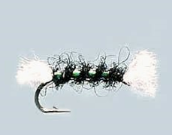
Hook :- Dry fly, 16-14-12. Kamasan B400 or similar

Tail :- White Antron yarn

Body :- Seals fur, original was olive

Rib :- Pearl Lurex or holographic tinsel

Breather :- White Antron yarn

The Shipman’s is another popular UK fly that is making its presence felt in Europe and, no doubt, in other places around the world. It is simple to tie and effective in use, which is about all you can ask of a fly. Paul Arden, who runs the Sexyloops website, reckons that in the days when he used to fish UK stillwaters the Shipman’s caught more fish than any other fly.

As stated, the Shipman’s is easy to tie. Lay your foundation thread from behind the eye to a point above the barb and attach a length of white Antron yarn. White wool, acrylic yarn, or Float-Vis will all serve just as well although wool will soak up water and you will have to use floatant on it. Lay the yarn along the hook so that you have a few millimetres overhanging the eye and the bend. Bind it down to a point just behind the eye and then take the thread back to above the bend. Attach the Lurex or holo tinsel ( ordinary silver tinsel will do ) and tuck it out of the way in that spring most vices have. Now dub your thread with seals fur or your favourite substitute in the colour of your choice and form the body by winding it forward to the tie in point just behind the eye. The ribbing material is next and is counter-wound forward and secured at the front of the body material. Finish the fly by lifting the white breather material and putting a few turns of thread under it to lift it away from the eye. Whip finish, head cement on the knot and that’s it. The fly is designed to sit in, not on, the surface film so scruff up the seals fur with a piece of Velcro or tease out a few strands with a needle to help it do so.

The original, as tied by Dave Shipman, was intended to represent a hatching buzzer struggling in the meniscus. He used the materials listed above but variations are common, the most common being black instead of olive for the body. But claret is also often used. There are versions around that have CDC tufts instead of the white Antron and even one that uses white foam (yuk). All of which just goes to show that the Shipman’s is a silhouette fly that is good to tie on when there’s a midge hatch going.

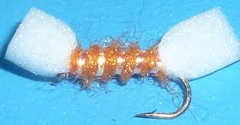
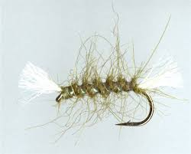

Alan T.
~~~~~~~~~~~~~~~~~~~~~~~~~~~~~~~~~~~~~~~~~~~~~~~~~~~~~~~~~~~~~~~~~

